Bilingual IFS
Integration Workshops
French/English

October 10-11, 2021
Rixensart (Belgium)

In these Integration Workshops, we combine everything that can support the Integration of the IFS Model in order to meet the needs, questions and requests of the participants, starting from what is alive in the group and the experience of each one. Each Module is therefore tailor-made in function of who is present.
We mix practical, theoretical and personal work in order to reduce the interference of our own system in the therapeutic process and to develop a supportive and adjusted quality of presence that elicits and strengthens the relationship between the Self of the person and its parts.
The supports proposed throughout the workshop will be varied:
Supervision of your practices, practice with personalized coaching, demos with debriefing, exercises on your own system, discovery of various work supports, experiments promoting awareness, role-playing, questions about theoretic points...
We will call upon the creativity of the Self to vary the proposals, the tracks and axes of work and exploration of our systems and will start from your questions, needs and requests.
In order to best support your progress and to enrich the contributions, we will be 4 trainers for this exceptional Bilingual workshop: Ariane Girard, Nadine d’ydewalle and Bernard Piaget will lend me a helping hand to accompany you in the best possible way. They all are experimented IFS practitioners and trainers, are trained in IFIO (relational IFS therapy, couples) and for IFS and children.
We will spend some time all together, to taste the links and dynamics of a large group. And we will spend a good part of the time in two distinct groups, to accompany you at best in either French or English.
Each IFS Integration workshop validate 12 hours of continuing education in the IFS-Institute certification process.
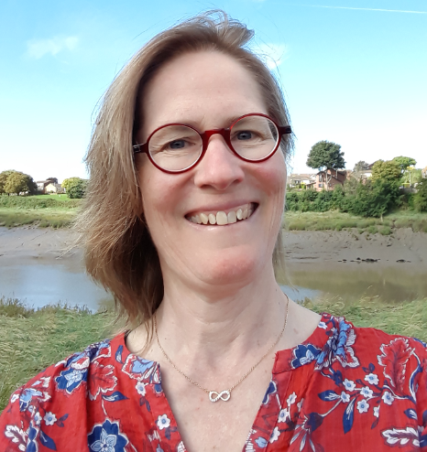
Organised by Vinciane van Outryve
Certified IFS therapist
Trainer and Supervisor
Trained in IFIO (Relational IFS therapy, couples),
IFS for children

Practical Information – IFS Integration Workshop

Schedule: Day 1: 9:00 am – 6 :00 pm
Day 2: 9:30-17h
Welcome from 9 :00 am

Price : For your first workshop of the year: 280 € (231 € facilitation + 49 € VAT)
Per following workshop during the year: 240 € (198 € facilitation + 42 € VAT)
Prerequisite: IFS Level 1

Application Form – IFS Integration Workshop

Name: First name:
Street and N°: Zip code and town:
Phone number: Email address:
IFS Education:
Name of the bank transfer, if different:

I register for the IFS Integration Workshop of October 10-11 in Rixensart and indicate my language choice:
O English speaking Practice Groups O Practice groups in either French or English
I make a bank transfer of 130 € deposit on following bank account
O Belgium: IBAN BE91 7320 2485 3976 - BIC CREGBEBB
O France: IBAN FR76 3002 7172 5200 0203 3500 106 - BIC CMCIFRPP
with as communication your name and IFS Workshop October 10-11
The remaining balance of 150 € or 110 € has to be paid by bank transfer before October 1rst.
The workshop will be confirmed as soon as the minimum number of participants is reached and no later than one month before the start of the module.

Cancellation conditions:
You cancel within the month of your registration: cancellation without charge.
Three months before the workshop: half of the deposit is refunded,
Two months before the workshop: the deposit is due and is not refunded,
One month before the workshop: the total price of the workshop is due.
The sums paid for the workshop are fully refunded if we have to cancel it or if a person on the waiting list takes your place. We do not intervene in the accommodation and transport costs caused by a cancellation for reasons outside our control (Corona style...).

O I accept that my contact information will be sent to the participants of this workshop when it is confirmed, in order to encourage carpooling and the exchange of offers and requests for accommodation. This will facilitate the organization of people who come from far away!
Each IFS Integration workshop validate 12 hours of continuing education in the IFS-Institute certification process.

Date Signature

